Intro to Arduino IDE and Hello World
Arduino IDE
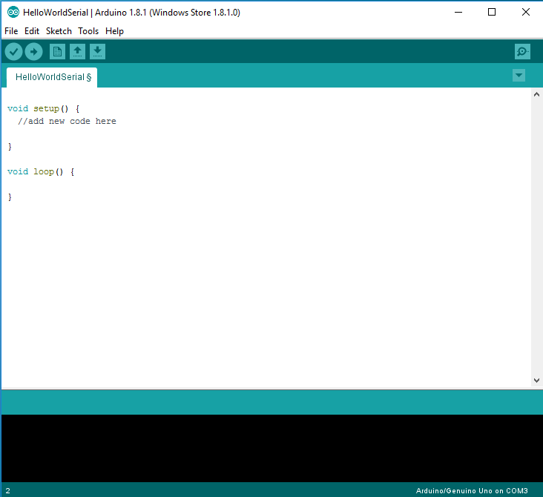
The Arduino Integrated Development Environment (IDE) is a suite of open source tools used to write, load, and debug code for the Arduino. An Arduino program is referred to as a 'sketch.' Make sure your Arduino is connected to the computer using the USB cable, then open up the provided sketch, HelloWorldSerial.ino.
This sketch, as currently written, doesn't actually do anything; but that doesn't mean we can't compile, load, and run it.

- Start by pressing the verify button.

This compiles the code; which means it takes the human readable source code, and turns it into a machine executable binary file. During this step, we will discover if our code contains any errors; if errors exist, the compilation will fail and the IDE will output the issues which prevented it from compiling.

- Next, use the upload button to send this code to the Arduino.

You should see the process complete, and the IDE will report that the upload is done. It should be noted that pressing upload automatically compiles your code before uploading, you don't need to press verify first, if you are ready to upload.
Hello World
It's traditional for programmers encountering a new language to write a very simple program, called a 'hello world' program, in which they confirm that their system is successfully configured to run their code. This program typically just prints the phrase 'Hello World' to the screen. Since we are working with an Arduino, which does not have a screen, our Hello World program will be slightly more complicated. It will print the phrase "Hello World" to the serial port, and our computers will then print it to the screen.

- Locate the comment that shows us where in the sketch to start adding new code.
- Start by adding the following line exactly as written:
Serial.begin(9600);
This line tells the Arduino to start a serial connection with the computer, at a speed of 9600 baud.

- Go down to the next line and write:
while(!Serial) {}
We will talk more about control structures and loops later. For now, it will suffice to say that this line of code waits for the serial connection to be established before proceeding.

- Finally, add the following line to complete
Serial.println("Hello World");

This line writes the text “Hello World” to the serial line. If everything goes well, we should see it appear on the serial monitor when we run this program.

- Save your progress, then press the upload button.
- When the upload completes, open the serial monitor.
- Make sure that the baud rate for the monitor matches the baud rate we defined in our program (9600).

You should see the text 'Hello World' appear on screen. Welcome to the world of Arduino!

